QMD2_Assignment

Mustafa Sanli

8/10/23

# Manifest (TV Series)

## 1. Description of the Show

Manifest is an American supernatural drama television series created by *Jeff Rake* that premiered on September 24, 2018, on NBC. It centers on the passengers and crew of a commercial airliner who suddenly reappear after being presumed dead for five and a half years. It stars *Melissa Roxburgh*, *Josh Dallas*, *Athena Karkanis*, *J. R. Ramirez*, *Luna Blaise*, *Jack Messina*, *Parveen Kaur*, *Matt Long*, *Holly Taylor*, *Daryl Edwards*, and *Ty Doran*.

## 2. Logo of Manifest

|  |
| --- |
| Manifest Logo |

## 3. Some basic statistics

* The first episode was watched by 12.8 million viewers on 16 September 2018.
* The show was watched by an average of 8.2 million viewers.
* Manifest was cancelled by NBC in 2022. However, the show was acquired by Netflix and will return in 2023 with a six-episode final season.

## 4. Graph of the viewership

import matplotlib.pyplot as plt  
  
# Import the data  
data = [12.8, 7.8, 5.4, 4.2]  
x_values = range(1, len(data) + 1)  
  
# Graph  
plt.plot(x_values, data)  
plt.xlabel("Episodes")  
plt.ylabel("Avg. Viewership (in millions)")  
plt.title("Viewership of Manifest Series Over Time")  
plt.xticks(x_values)  
plt.show()

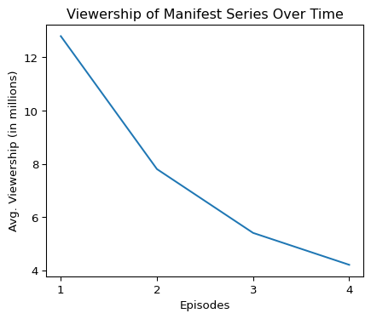

## 5. Graph of the Episode-to-Episode Changes in Viewership

import pandas as pd  
import matplotlib.pyplot as plt  
  
# Import the data.  
data2 = pd.read_csv("episodes_viewership.csv")  
  
# Get the episode number, season, viewership, and change from previous episode.  
episode = data2["Episode"]  
season = data2["Season"]  
viewership = data2["Viewership (millions)"]  
change = data2["Change from previous episode"]  
  
# Plot the episode-to-episode viewership.  
plt.plot(episode, viewership)  
  
# Add a title and labels to the axes.  
plt.title("Manifest Episode-to-Episode Viewership")  
plt.xlabel("Episode")  
plt.ylabel("Avg. Viewership (in millions)")  
  
# Show the plot.  
plt.show()

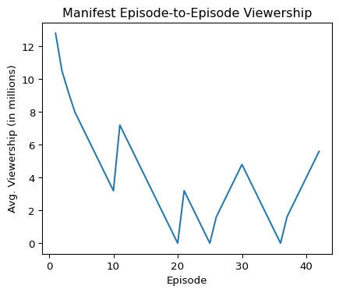

## 6. Short Description of the Observed Changes

changes = data[0] - data[1]  
print("The viewership decreased by " +str(changes)[:3]+ " million viewers between seasons 1 and 2.")

The viewership decreased by 5.0 million viewers between seasons 1 and 2.